NETWORK TOPOLOGIES THEORY

Day2
TASK1: Draw a diagram of a bus topology and label all key components, then write one real-world example where this topology might be used.
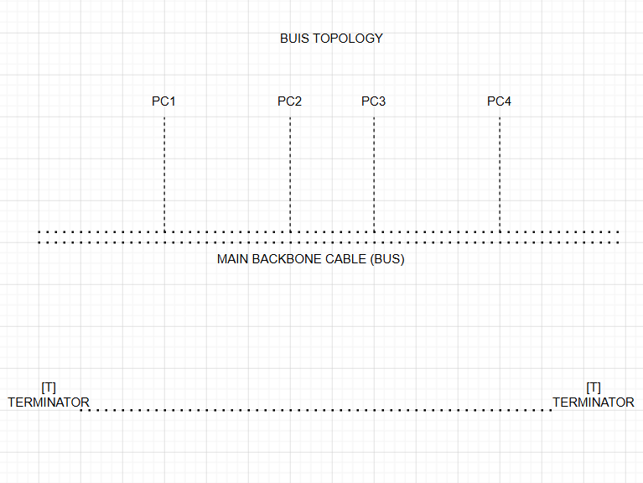

TASK2: In Cisco Packet Tracer, create a simple star topology with one switch and four PCs connected to it; name each PC after a popular app (e.g., WhatsApp, Zomato, Spotify, Flipkart) and take a screenshot of your topology.
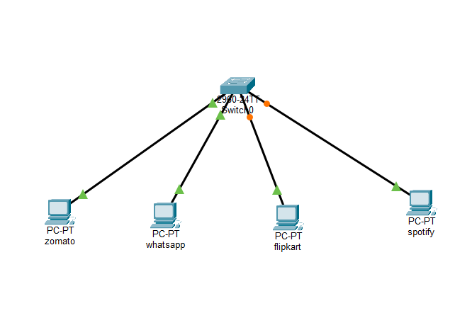
TASK3: Draw a ring topology diagram and explain in 2-3 sentences how data travels between devices in this setup.<br><br><em><strong>Hint:</strong> Use arrows to show the direction of data flow.</em>
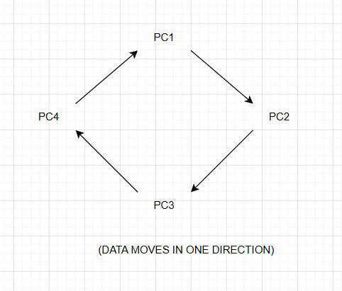
In a Ring Topology, each computer is connected to two other computers, forming a closed circle. Data travels in one direction around the ring until it reaches the destination device. If one connection fails, communication may stop unless a dual-ring system is used.

TASK4: Compare mesh and star topologies by listing 2 advantages and 2 disadvantages of each in a table format.
Feature | Mesh Topology | Star Topology
Advantage 1 | Very reliable because multiple paths are available. | Easy to install and manage.
Advantage 2 | If one cable fails, communication continues. | Easy to add or remove devices.
Disadvantage 1 | Requires many cables. | If the central switch fails, the whole network stops.
Disadvantage 2 | High installation cost. | Uses more cable than Bus topology.

